**Graph**

A graph can be defined as group of vertices and edges that are used to connect these vertices. A graph can be seen as a cyclic tree, where the vertices (Nodes) maintain any complex relationship among them instead of having parent child relationship.

## **Definition**

A graph G can be defined as an ordered set G(V, E) where V(G) represents the set of vertices and E(G) represents the set of edges which are used to connect these vertices.

A Graph G(V, E) with 5 vertices (A, B, C, D, E) and six edges ((A,B), (B,C), (C,E), (E,D), (D,B), (D,A)) is shown in the following figure.

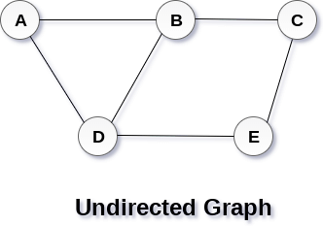

## **Directed and Undirected Graph**

A graph can be directed or undirected. However, in an undirected graph, edges are not associated with the directions with them. An undirected graph is shown in the above figure since its edges are not attached with any of the directions. If an edge exists between vertex A and B then the vertices can be traversed from B to A as well as A to B.

In a directed graph, edges form an ordered pair. Edges represent a specific path from some vertex A to another vertex B. Node A is called initial node while node B is called terminal node.

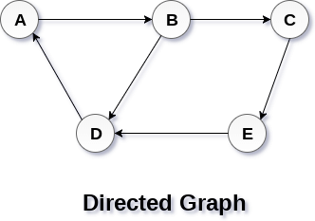

## **Graph Terminology**

### **Path**

A path can be defined as the sequence of nodes that are followed in order to reach some terminal node V from the initial node U.

### **Closed Path**

A path will be called as closed path if the initial node is same as terminal node. A path will be closed path if V0=VN.

### **Simple Path**

If all the nodes of the graph are distinct with an exception V0=VN, then such path P is called as closed simple path.

### **Cycle**

A cycle can be defined as the path which has no repeated edges or vertices except the first and last vertices.

### **Connected Graph**

A connected graph is the one in which some path exists between every two vertices (u, v) in V. There are no isolated nodes in connected graph.

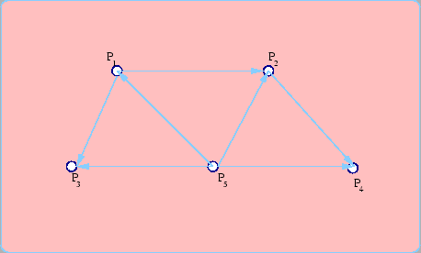

### **Complete Graph**

A complete graph is the one in which every node is connected with all other nodes. A complete graph contain n(n-1)/2 edges where n is the number of nodes in the graph.

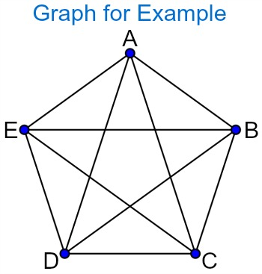

### **Weighted Graph**

In a weighted graph, each edge is assigned with some data such as length or weight. The weight of an edge e can be given as w(e) which must be a positive (+) value indicating the cost of traversing the edge.

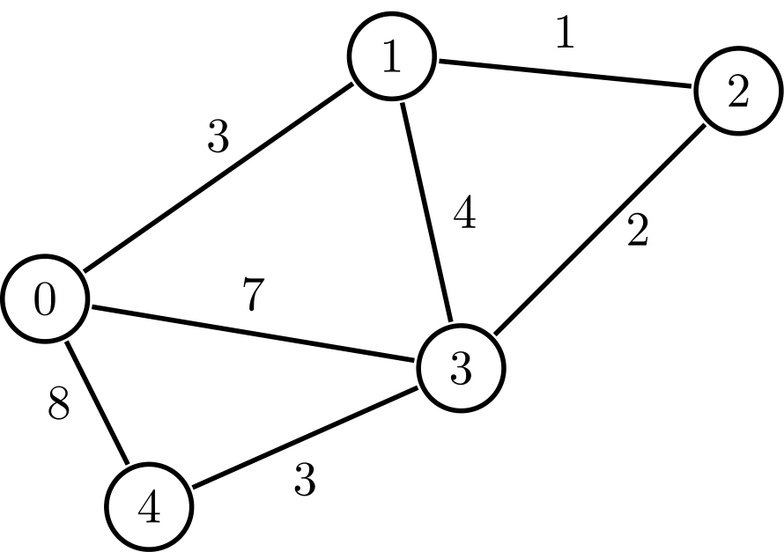

### **Digraph**

A digraph is a directed graph in which each edge of the graph is associated with some direction and the traversing can be done only in the specified direction.

### **Loop**

An edge that is associated with the similar end points can be called as Loop.

### **Adjacent Nodes**

If two nodes u and v are connected via an edge e, then the nodes u and v are called as neighbours or adjacent nodes.

### **Degree of the Node**

A degree of a node is the number of edges that are connected with that node. A node with degree 0 is called as isolated node.

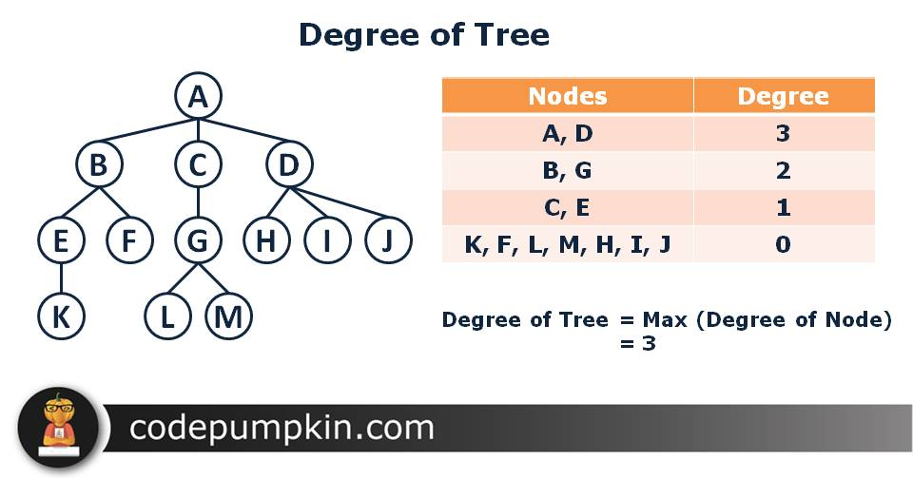

# Graph representation

A graph is a data structure that consist a sets of vertices (called nodes) and edges. There are two ways to store Graphs into the computer's memory:

* **Sequential representation** (or, Adjacency matrix representation)
* **Linked list representation** (or, Adjacency list representation)

In sequential representation, an adjacency matrix is used to store the graph. Whereas in linked list representation, there is a use of an adjacency list to store the graph.

### **Sequential representation**

In sequential representation, there is a use of an adjacency matrix to represent the mapping between vertices and edges of the graph. We can use an adjacency matrix to represent the undirected graph, directed graph, weighted directed graph, and weighted undirected graph.

If adj[i][j] = w, it means that there is an edge exists from vertex i to vertex j with weight w.

An entry Aij in the adjacency matrix representation of an undirected graph G will be 1 if an edge exists between Vi and Vj. If an Undirected Graph G consists of n vertices, then the adjacency matrix for that graph is n x n, and the matrix A = [aij] can be defined as -

aij = 1 {if there is a path exists from Vi to Vj}

aij = 0 {Otherwise}

It means that, in an adjacency matrix, 0 represents that there is no association exists between the nodes, whereas 1 represents the existence of a path between two edges.

If there is no self-loop present in the graph, it means that the diagonal entries of the adjacency matrix will be 0.

Now, let's see the adjacency matrix representation of an undirected graph.

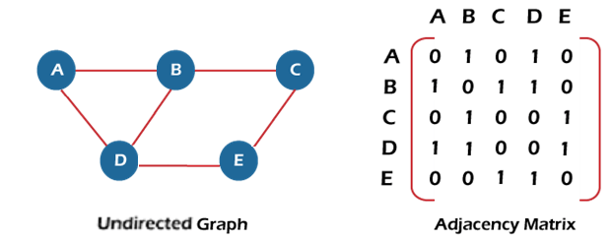

### **Adjacency matrix for a directed graph**

In a directed graph, edges represent a specific path from one vertex to another vertex. Suppose a path exists from vertex A to another vertex B; it means that node A is the initial node, while node B is the terminal node.

Consider the below-directed graph and try to construct the adjacency matrix of it.

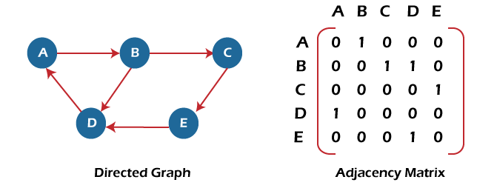

**Adjacency matrix for a weighted directed graph**

It is similar to an adjacency matrix representation of a directed graph except that instead of using the '1' for the existence of a path, here we have to use the weight associated with the edge. The weights on the graph edges will be represented as the entries of the adjacency matrix. We can understand it with the help of an example. Consider the below graph and its adjacency matrix representation. In the representation, we can see that the weight associated with the edges is represented as the entries in the adjacency matrix.

